**AI-Based Chatbot for Mental Health Support**

**1. Problem Understanding and Overview**

**1.1 Problem Summary**

Mental health issues are a growing concern globally, affecting individuals across all age groups. However, access to timely, affordable, and stigma-free mental health support remains limited. Many people avoid seeking help due to societal judgment, high costs, or lack of availability, especially in rural or underserved regions. This growing gap calls for innovative solutions to make mental health support more accessible and responsive.

**1.2 Business Goals**

The primary business goal is to develop a scalable, AI-powered chatbot that can simulate empathetic human conversations, detect emotional states, and offer supportive suggestions or interventions. This tool aims to act as a first line of communication for those who are struggling, thereby reducing the load on mental health professionals while providing constant, anonymous, and safe emotional support.

**1.3 Objectives**

* To create an AI chatbot capable of understanding user emotions through natural language inputs.
* To provide real-time, relevant, and supportive mental health responses.
* To maintain user privacy and confidentiality.
* To support early detection of potential crises and refer users to professional help when needed.

**2. Proposed Solution**

**2.1 Solution Overview**

The proposed solution is an AI-based chatbot that uses NLP (Natural Language Processing) and machine learning models to detect user emotions and provide supportive responses. Built using BERT-based models for emotion detection, it aims to act like a virtual mental health assistant.

**2.2 Step-by-Step Approach**

1. **Requirement Analysis:** Understand the specific mental health use cases to target.
2. **Data Collection & Preprocessing:** Collect conversational data related to mental health (CSV format) and clean it for model training.
3. **Model Development:** Train a BERT-based emotion detection model using Hugging Face or similar tools.
4. **Frontend Development:** Create a visually calming and friendly user interface using HTML, CSS, and JavaScript.
5. **Backend Integration:** Use Python with Flask or FastAPI to connect the frontend with the model.
6. **Testing & Deployment:** Host the solution on Render or Hugging Face Spaces for accessibility.

**2.3 Data and Input Sources**

* Publicly available mental health-related datasets
* Custom-built CSV datasets with labeled emotions (happy, sad, angry, etc.)
* User input via chatbot UI for real-time processing

**3. Key Features of the Solution**

**3.1 Key Features**

* **Emotion Detection:** Analyzes text to classify user emotions.
* **Human-like Responses:** Offers supportive, empathetic replies similar to a counselor.
* **Crisis Alert System:** Detects signs of suicidal thoughts or crisis situations and issues alerts.
* **User-friendly Interface:** Interactive design with calming visuals and easy navigation.
* **24/7 Availability:** Always active chatbot, removing time-bound constraints.
* **Privacy-Focused:** No personal data storage, ensuring user anonymity.

**4. Expected Outcomes and Benefits**

**4.1 Business Benefits**

* Cost-effective mental health assistance for institutions (schools, workplaces).
* Reduces burden on mental health professionals by acting as a first-line support.
* Enhances user engagement and satisfaction by offering continuous support.
* Potential for scaling into a paid SaaS platform for clinics and organizations.

**4.2 Risk Management**

* Implement filters to detect harmful language and redirect users in danger to professional help.
* Regular audits of AI responses to ensure they align with ethical mental health practices.
* Ensure data privacy through encryption and compliance with data protection regulations.

**5. Conclusion**

The AI-based mental health chatbot presents a transformative approach to providing emotional support in today’s digitally connected world. By blending artificial intelligence with human-centered design, the solution addresses key gaps in accessibility, affordability, and responsiveness in mental health care. With further development and integration into existing systems, it holds the potential to make mental wellness support universally available and impactful.

**6. References**

* World Health Organization: Mental Health Reports
* Hugging Face Transformers Documentation
* BERT-based Emotion Detection Papers
* Public Datasets (Kaggle, UCI) on Emotional Sentiment
* Mental Health Startup Case Studies (e.g., Wysa, Woebot)

INDEX.HTML

Emotionally supportive **wording/content** for your index.html page of the **AI-Based Mental Health Support Chatbot** — designed to welcome users, introduce your project, and lead them into the chatbot.

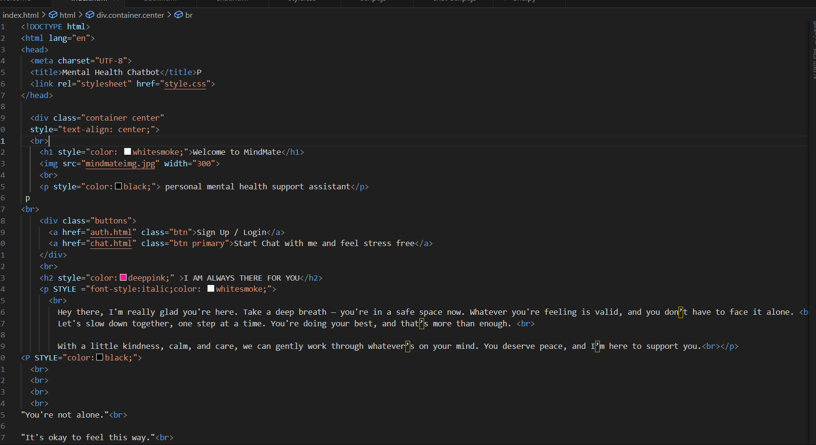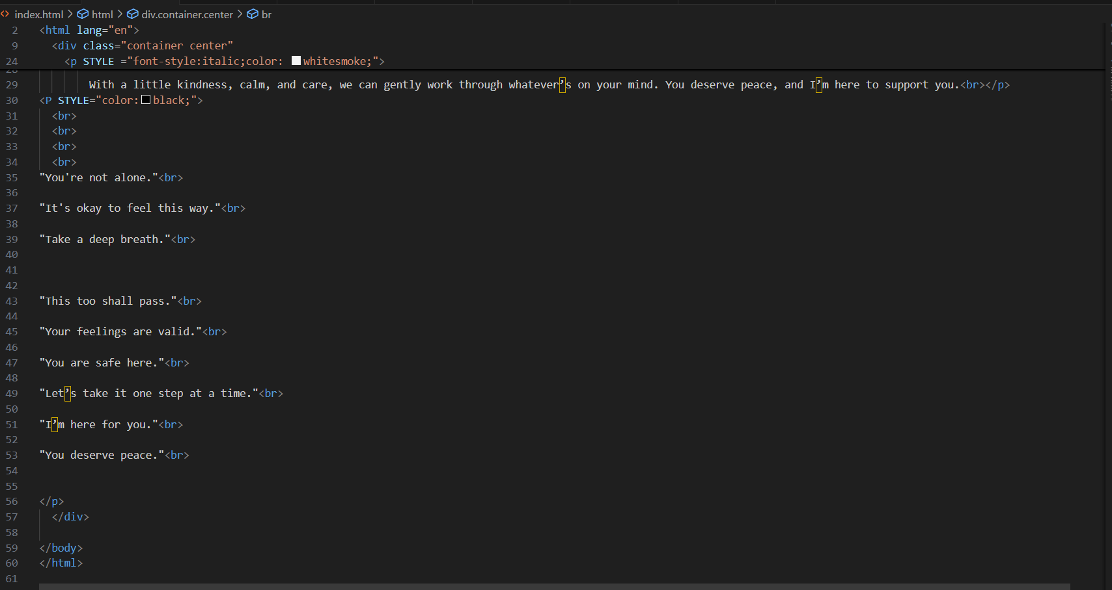

AUTH.HTML and CHAT.HTML

The content (text + structure) for your **auth.html** and **chat.html** pages for your AI-based mental health chatbot project.

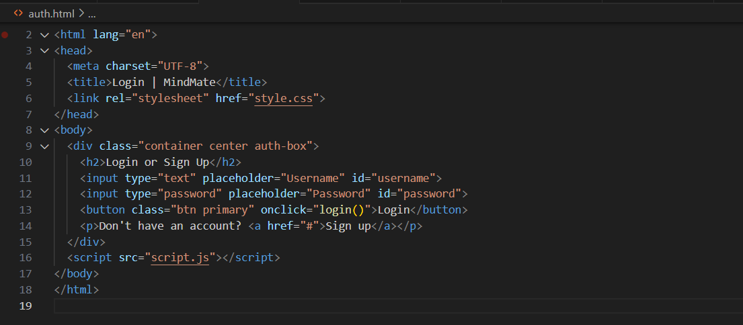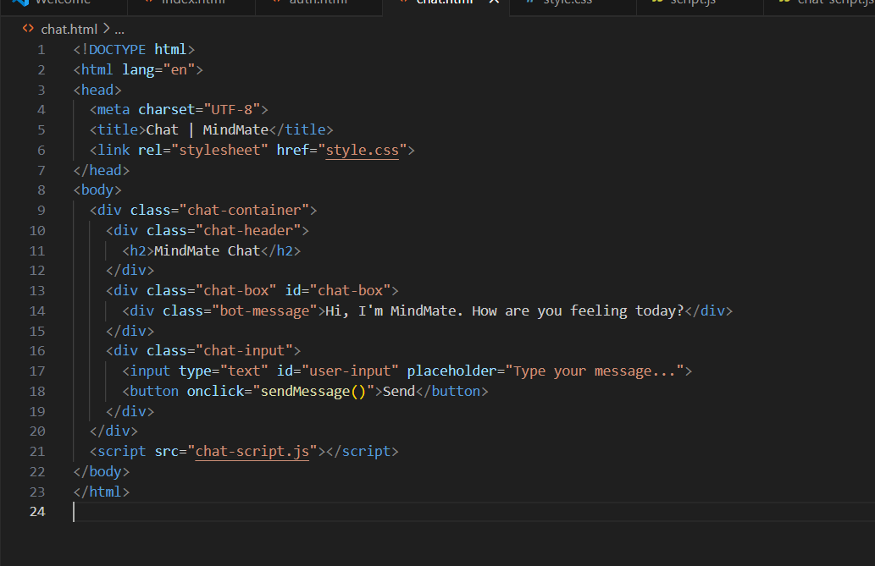

STYLE.CSS

CSS is what makes your chatbot look **professional, calming, and user-friendly**. While HTML gives structure (like chat boxes, buttons), CSS gives it **style** — color, spacing, fonts, and layout — making your mental health support app visually engaging and easier to use.

* **✅ How It Works:**
* **HTML = Structure**  
  Example: A button, a heading, a chat box.
* **CSS = Appearance**  
  CSS tells the browser *how* those elements should look:
  + What **color** should the button be?
  + What **font size** should the heading use?
  + How much **padding or margin** should be around the chat box?
* **Connecting CSS to HTML**  
  You link your CSS file inside the HTML:
* Html

.

**💡 Key Components:**

* **index.html:** Welcomes users with a calming message, image, and buttons to sign up or start chatting.
* **auth.html:** Allows users to sign up or log in with a clean, intuitive form.
* **chat.html:** Provides a live chat interface where users can type messages and receive AI-driven emotional support.
* **style.css:** A gentle, modern design with soft colors, rounded elements, responsive layout, and readability.
* **Backend (Flask or FastAPI):** Handles text inputs, detects emotions from messages using pre-trained NLP models, and generates supportive responses.

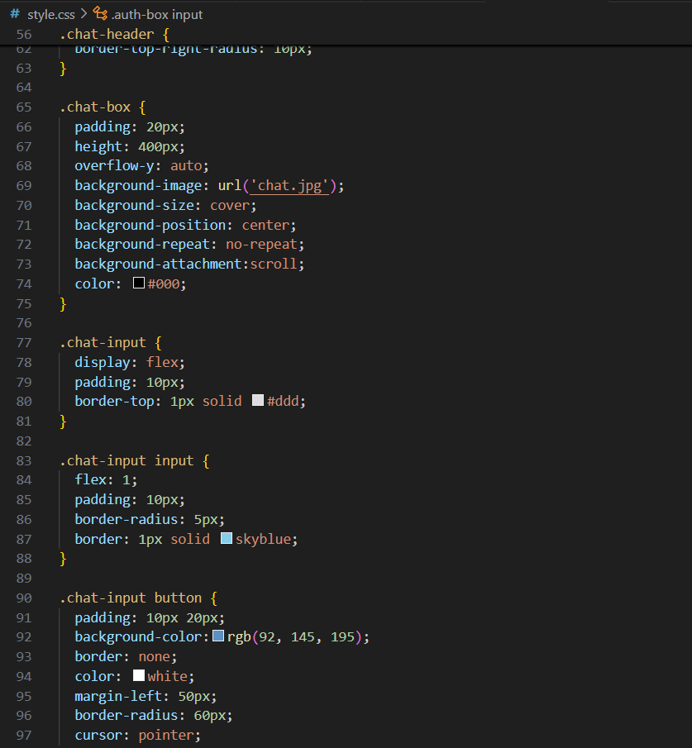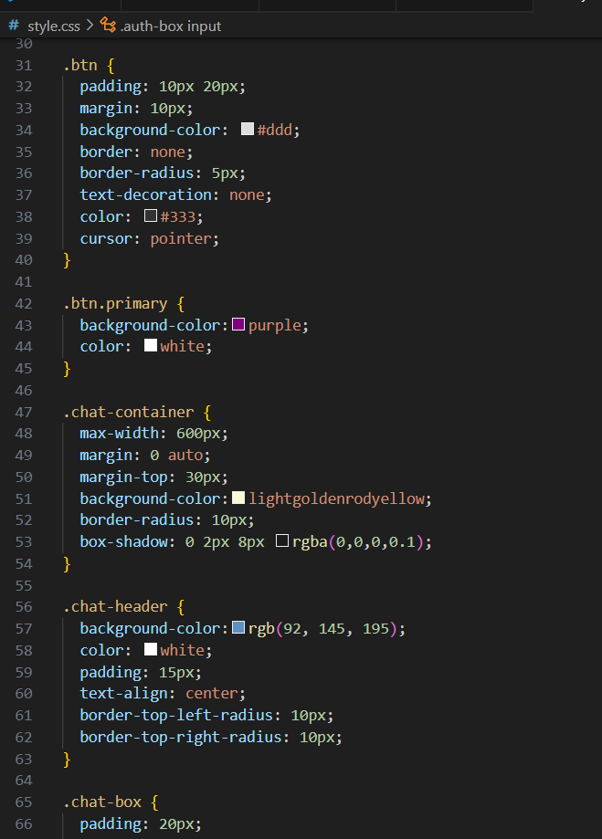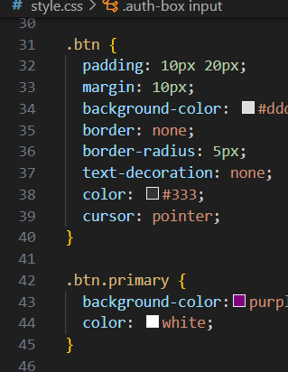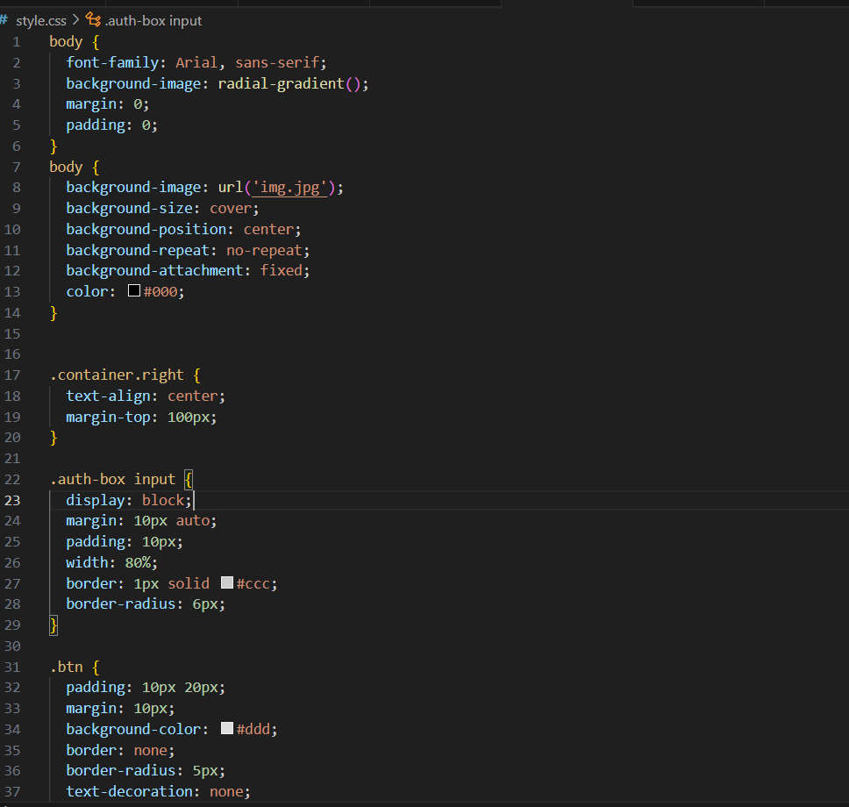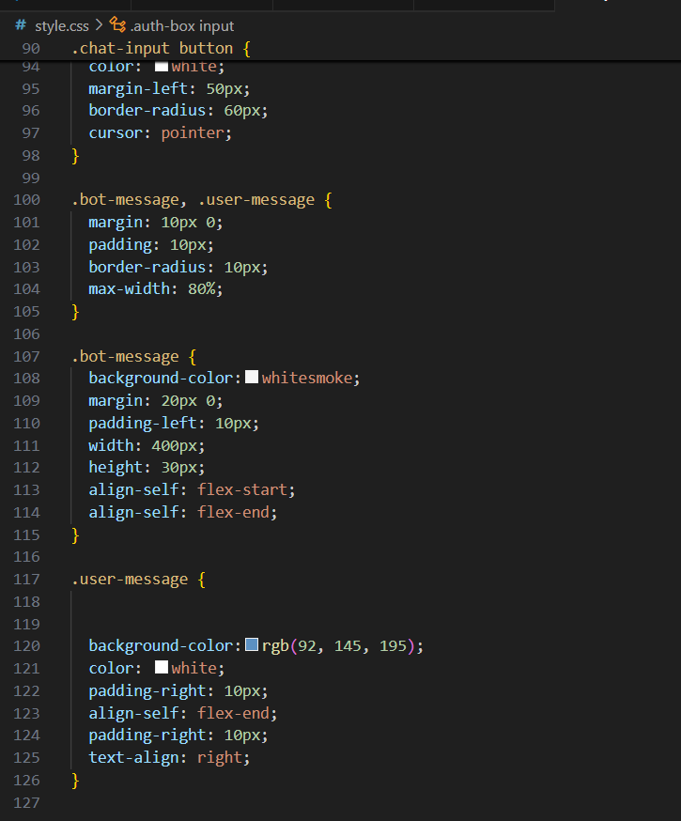

Script.js and chat-script.js

**✅ 1. script.js — *General UI Interactions (optional)***

Use this file if your homepage or login page has interactivity (like toggling between login and signup).

**🧠 What It Does:**

* Waits until the HTML loads.
* Listens for the "Sign Up" button click.
* Shows an alert or redirects as needed.

**✅ 2. chat-script.js — *Handles Chat Functionality***

* This script connects your frontend (chat.html) to your backend (Flask or FastAPI) and sends/receives chatbot messages.

It’s the **JavaScript file** that makes the **chatbot actually work** on your chat.html page. It:

1. Gets the message you type
2. Sends it to the **Python backend**
3. Receives the chatbot’s reply
4. Displays both messages in the chat window

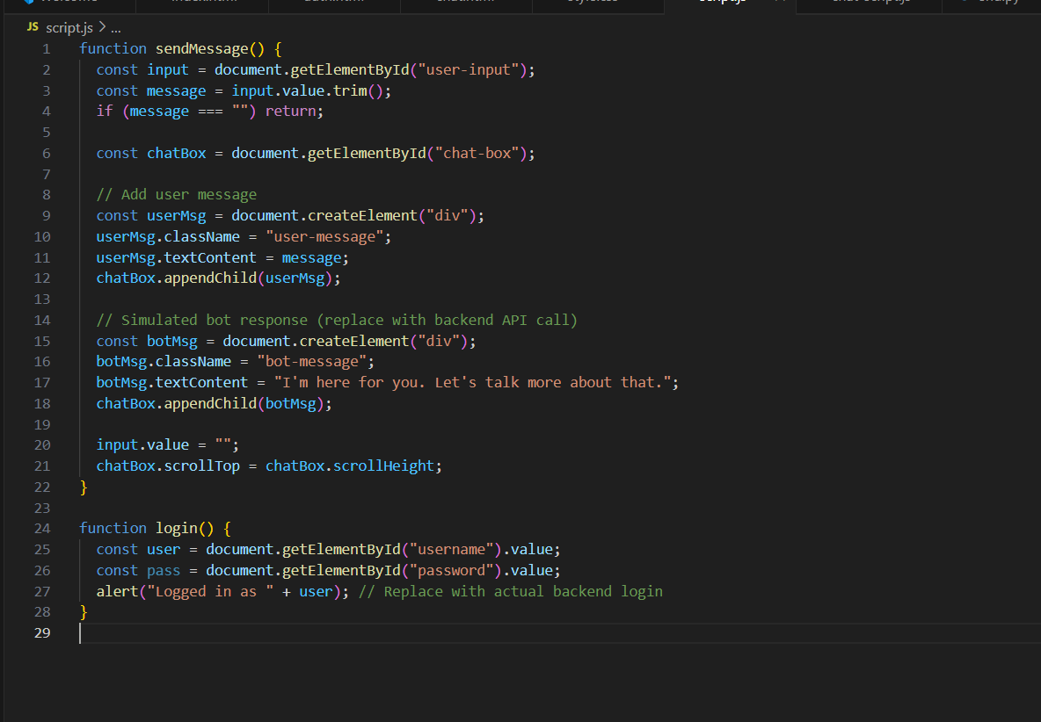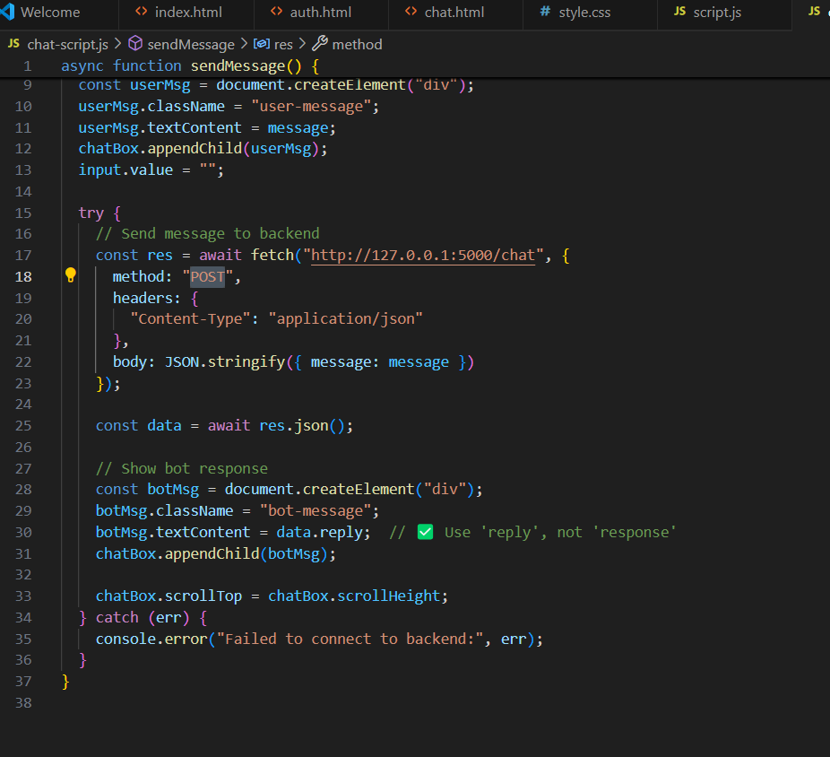

End.py

In your AI-based mental health chatbot project, the end.py file is used as the **backend** to process user messages and respond intelligently. Let's break down what end.py typically does in a chatbot backend:

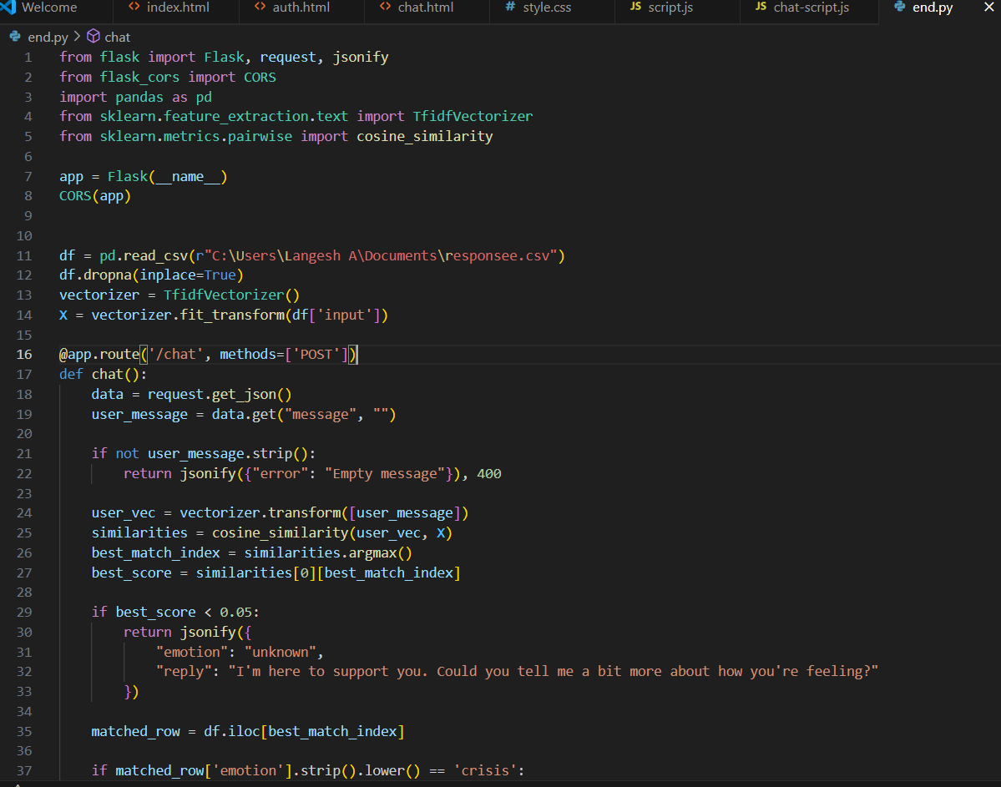

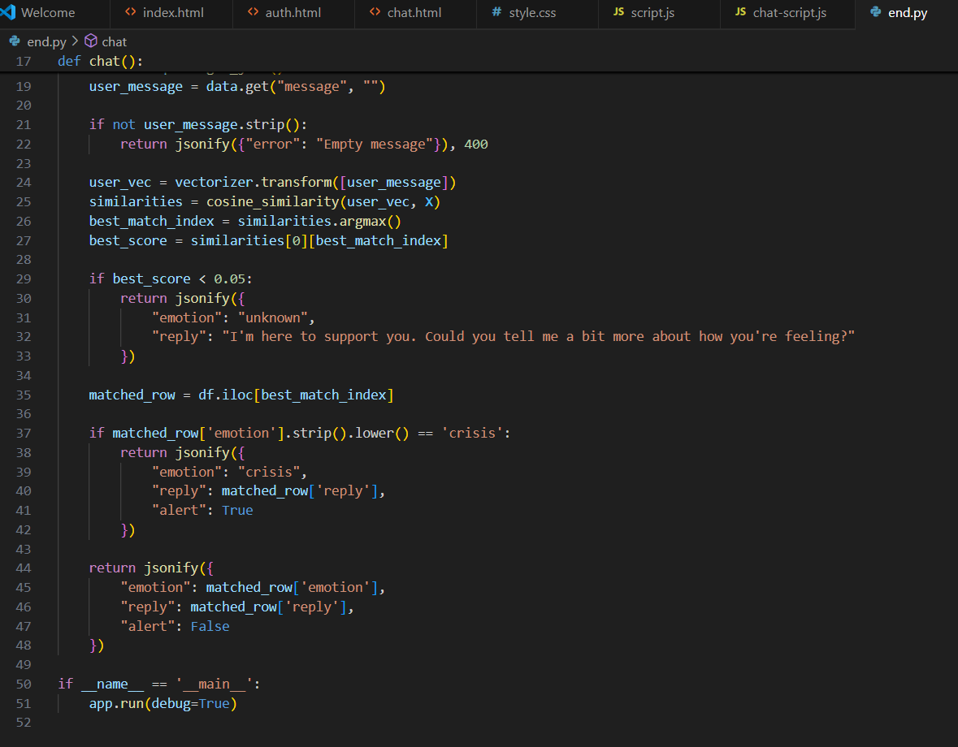

**OUPUT FOR AI-EBPL CHATBOT MENTAL HEALTH SUPPORT**

